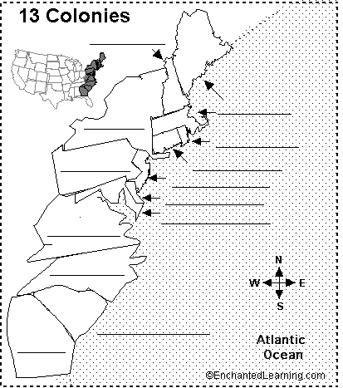
1. Label the 13 colonies by writing each state name on the line provided. Use the map on page 122 to help you. You must spell out each state name, do not use abbreviations.
Name______________
Date ______________
Period _____________
Use pages 120-124 in your book to help you complete the map.

New Hampshire(NH) New York(NY) Massachusetts(MASS) Rhode Island(RI) Delaware(DEL)
Virginia(VA) New Jersey(NJ) North Carolina(NC) South Carolina(SC)
Maryland(MD) Georgia(GA) Pennsylvania(PA) Connecticut(CONN)

2. Locate and Label the Appalachian Mountain Range.

3. Outline the New England Colonies-Yellow; the Middle Colonies-Red; the Southern Colonies-Green

4. List the primary industries and religions of each region on the states of that region.

5. Create a legend to identify the key for each piece of information on the map.

6. Write a paragraph on the back of the map summarizing what you learned about the 13 colonies.

